Agricultural Water Optimization Program
Utah Department of Agriculture and Food

The Utah Department of Agriculture and Food

January 4, 2022

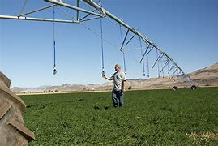

Contact

Jay Olsen
Utah Department of Agriculture and Food

(801) 718-0517

Email: jayolsen@utah.gov

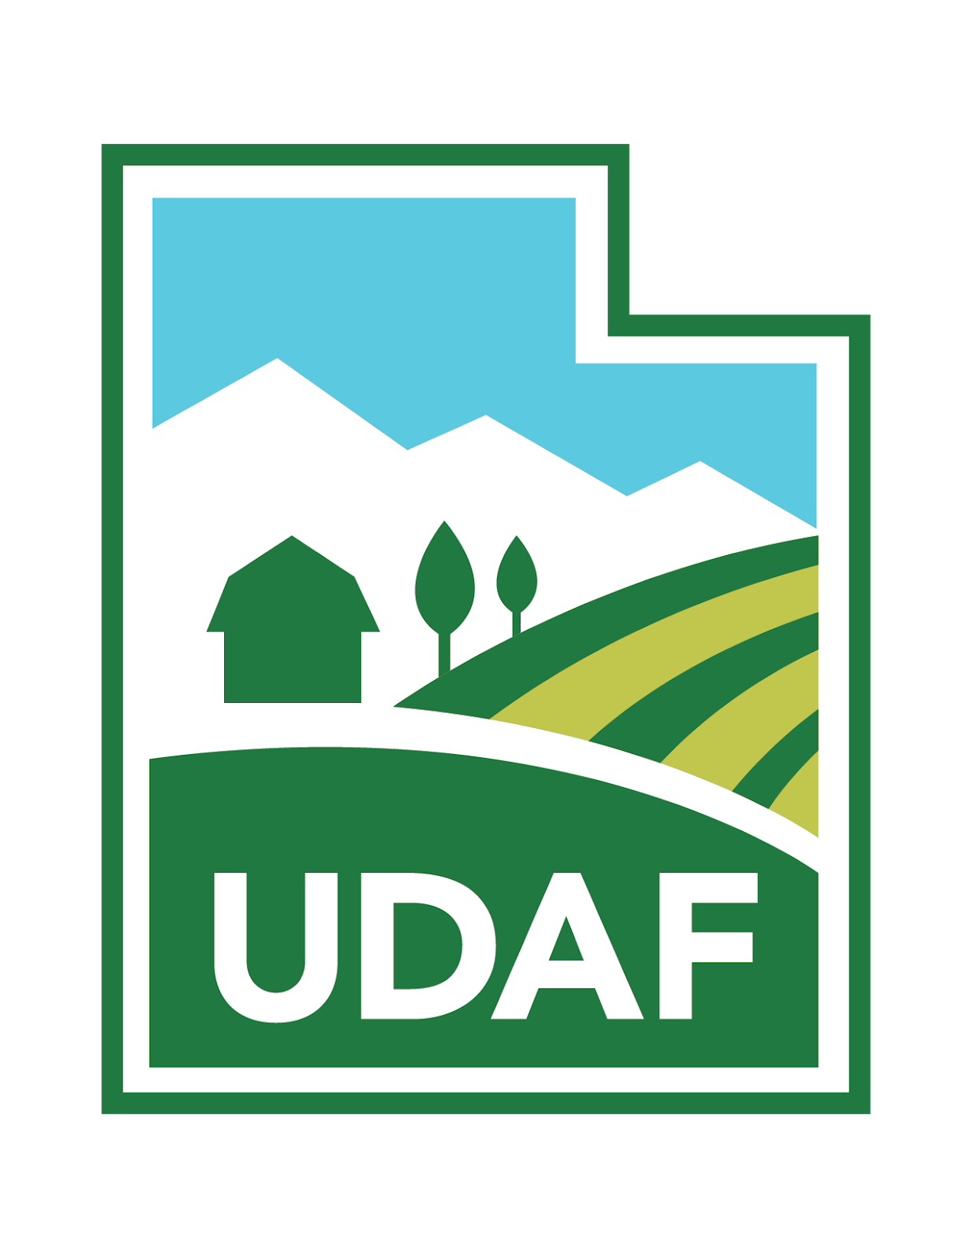

The purpose of the Agricultural Water Optimization Program
- Improve Water Optimization by reducing consumptive water use while maintaining or improving agriculture production and profitability, and providing increased operational flexibility for agriculture water users moving forward.
- Improve Water Quantification by showing accurate, real-time measurement of diverted water to demonstrate actual water savings in CFS and acre foot.
- Document the availability of water after implementation of a Water Optimization Project.
- Improve and protect surface and ground water quality by reducing overwatering of crops.
Program Information:
- $500,000 per project cap: special consideration may be given for projects which are located within areas showing increased pressure on water resources, or provide exceptional optimization benefits.
- 50/50 cost share: The Water Optimization Grant Program funds will be limited to 50% of the total cost of the project. We encourage seeking other funding sources for the remaining cost of the project.
- 10% cost: producers are required to contribute at least 10% of the cost of the project. This can include in-kind match (if there is a question on the value of in-kind match, it will be valued on NRCS EQIP cost list).
The Department of Agriculture and Food anticipates that they will be accepting 2022 applications for the Agriculture Water Optimization Program February 1st through April 15th. If you are interested in applying for this program you can visit the UDAF website: https://ag.utah.gov/farmers/conservation-division/water-optimization-program/ or contact Jay Olsen for more information.

