Musk Thistle

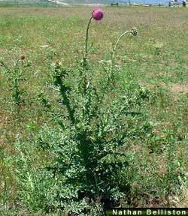
Identification:
Musk thistle is a biennial or winter annual. Four to six foot tall plants are common. The Deeply lobed leaves are distinguished by a dark green blade with a prominent light green midrib. The flowers may be violet, purple, or rose colored. Flowers are typically "nodding" or bent over. Ends of stems supporting flowers are often nearly leafless. Musk thistle usually blooms in June and July. Seeds are attached to soft parachute-like plumes.
Habitat:
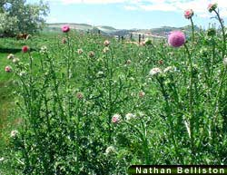
Native to southern Europe and western Asia, musk thistle thrives in pastures and range lands, in waste areas, stream banks, and road sides. Vigorously growing grass competes with musk thistle, and fewer thistles occur in pastures where grazing is deferred. However, musk thistle also can become a problem in pasture or rangeland that is in good condition.

Management
Cultural control:
Maintaining pastures and rangeland in good condition is a primary factor for musk thistle management. To favor pasture and rangeland grass growth, do not overgraze. Fertilize only when necessary and according to soil testing recommendations. To successfully manage musk thistle, prevent seed formation.
Mechanical control:
Musk thistle will not tolerate tillage and can be removed easily by severing its root below ground with a shovel or hoe. Mowing can effectively reduce seed output if plants are cut when the terminal head is in the late-flowering stage. Gather and burn mowed debris to destroy any seed that has developed.
Chemical control:
Several herbicides are registered in pasture, rangeland and noncrop areas to control musk thistle. Tordon 22K (picloram), Milestone (aminopyralid), Transline (clopyralid), Perspective (aminocyclopyrachlor + chlorsulfuron), Banvel/Vanquish/Clarity (dicamba), 2,4-D, or Banvel/Vanquish/Clarity plus 2,4-D are commonly used. Apply these herbicides in spring or fall to musk thistle rosettes.

