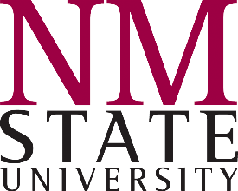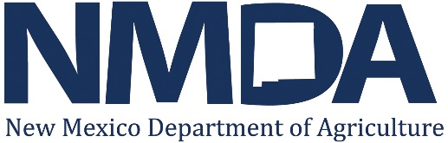

The Current Risks of Using Animas/San Juan River Water on Crops Following Mine Spill

Following the mine spill in southwestern Colorado, emergency managers at the local, county, state, and federal levels of government are advising farmers along the Animas River and the affected stretch of the San Juan River in northwestern New Mexico: No matter the visual appearance of the river water, do not use it to irrigate your crops until government officials declare it safe to use again.

Farmers who go against this advice run the following risks:
- Crops where the edible portion of the plant is the active growing portion or is in direct contact with contaminated water and soil, may absorb the contaminants released in the spill. These plants include but are not limited to: Leafy vegetables such as spinach, lettuce, and celery, as well as root crops such as carrots, potatoes, beets, and radishes.
- Flood irrigation will carry suspended particles and dissolved metals into the field where they can attach themselves to plants and soil.

From U.S. Environmental Protection Agency (EPA):
Threshold levels of metals dissolved* in water (don’t use water with concentrations above these levels)
Element | Drinking water MCL | Irrigation water
 | μg/L  (micrograms per liter or parts per billion) | μg/L  (micrograms per liter or parts per billion)
Arsenic | 10 | 2,000
Cadmium | 5 | 50
Iron | 300 | 20,000
Lead | 15 | 10,000
Mercury | 2 | 2
Zinc | 2,000 | 10,000
MCL = maximum contaminant levels
*The term “dissolved” refers specifically to the metals still present in the water sample after passing through a tiny filter. A “dissolved metals” analysis of a water sample is done by removing the particulates with a filter, then analyzing the filtered water for metals. The most common filters used for this purpose have a 0.45 μm (micrometer) pore size – less than the diameter of a strand of human hair.
Guidelines for the reuse of water for irrigation were found at: http://nepis.epa.gov/Adobe/PDF/30006MKD.pdf

All content provided in this handout is for informational purposes only. Although every reasonable effort has been made to present current and accurate information, NMSU and NMDA make no guarantees of any kind and cannot be held liable for any outdated or incorrect information.

